# **Name: Abdurrahman Qureshi**

# **Roll No: 210451**

Practical No: 21N22

**1)** **WAP in Java to create two threads. One will print even numbers from 1 to 10 and other will print odd numbers from 1 to 10**

**CODE:**

public class TransferThread {

public static void main(String[] args) {

Thread threadX = new Thread(new PrintNumbers1(), "ThreadX");

Thread threadY = new Thread(new PrintNumbers2(), "ThreadY");

threadX.start();

threadY.start();}

static class PrintNumbers1 implements Runnable {

public void run() {

for (int i = 1; i <= 10; i++) {

System.out.println(Thread.currentThread().getName() + ": " + i);}}}

static class PrintNumbers2 implements Runnable {

public void run() {

for (int i = 10; i >= 1; i--) {

System.out.println(Thread.currentThread().getName() + ": " + i);}}}}

**OUTPUT:**

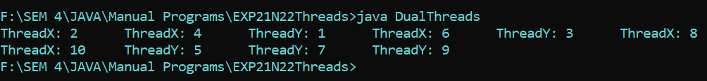

**2)WAP to define two thread one to print 1 to 10 and other to print 10 to 1. First thread transfer control to second thread after delay of 500ms**

**CODE:**

public class ThreeThreadsPriorities {

public static void main(String[] args) {

Thread threadX = new Thread(new PrintNumbers(1, 10), "Thread 1");

Thread threadY = new Thread(new PrintNumbers(11, 20), "Thread 2");

Thread threadZ = new Thread(new PrintNumbers(21, 30), "Thread 3");

threadX.setPriority(Thread.MIN_PRIORITY);

threadY.setPriority(Thread.NORM_PRIORITY);

threadZ.setPriority(Thread.MAX_PRIORITY);

threadX.start();

threadY.start();

threadZ.start();}

static class PrintNumbers implements Runnable {

private final int start;

private final int end;

public PrintNumbers(int start, int end) {

this.start = start;

this.end = end;}

public void run() {

for (int i = start; i <= end; i++) {

if (i == 10) {

System.out.println();}

System.out.print(Thread.currentThread().getName() + ": " + i + "\t");}}}}

**OUTPUT:**

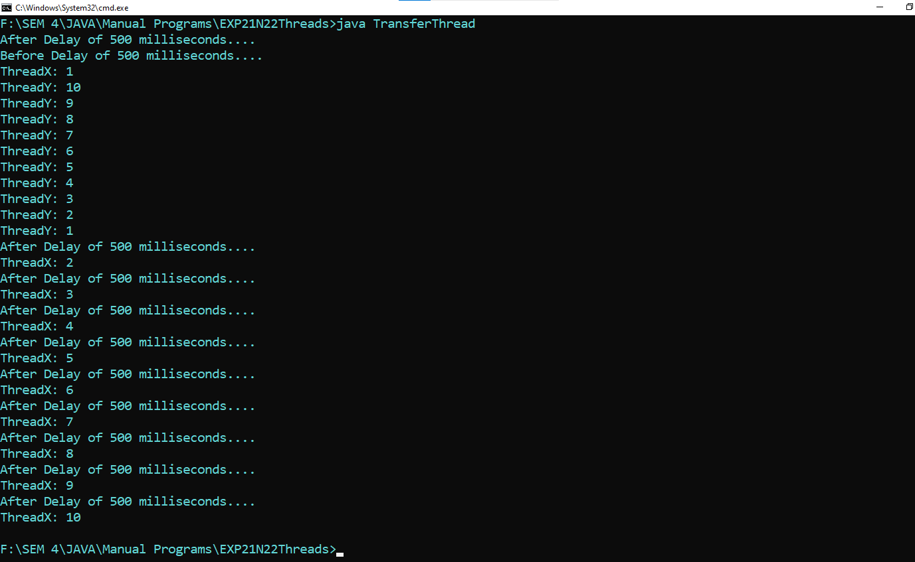

**3)** **WAP in Java to create three threads. Assign minimum priority to thread 1 which will print 1 to 10. Assign maximum priority to thread 3 which will print 21 to 30. Thread 2 will print 11 to 20. Use priority methods. (getPriority and setPriority)**

**CODE:**

public class ThreeThreadsPriorities {

public static void main(String[] args) {

Thread threadX = new Thread(new PrintNumbers(1, 10), "Thread 1");

Thread threadY = new Thread(new PrintNumbers(11, 20), "Thread 2");

Thread threadZ = new Thread(new PrintNumbers(21, 30), "Thread 3");

threadX.setPriority(Thread.MIN_PRIORITY);

threadY.setPriority(Thread.NORM_PRIORITY);

threadZ.setPriority(Thread.MAX_PRIORITY);

threadX.start();

threadY.start();

threadZ.start();}

static class PrintNumbers implements Runnable {

private final int start;

private final int end;

public PrintNumbers(int start, int end) {

this.start = start;

this.end = end;}

public void run() {

for (int i = start; i <= end; i++) {

if (i == 10) {

System.out.println();}

System.out.print(Thread.currentThread().getName() + ": " + i + "\t");}}}}

**OUTPUT:**

